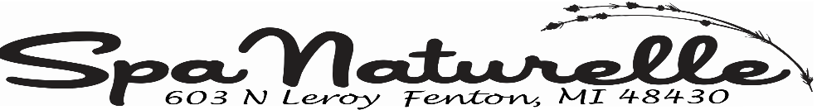
Consent for Services during Covid-19 Pandemic
Spa Naturelle Standards of Practice
I understand that the novel coronavirus causes the disease known as COVID-19. I understand the novel coronavirus has a long incubation period during which the carriers of the virus may not show symptoms and may still be contagious.
I understand that physical distancing of 6 feet may not be possible while in the spa receiving services.
I confirm that I am not currently positive for novel coronavirus.
I confirm that I am not waiting for the results of a laboratory test for the novel coronavirus.
I verify that I have not returned to Michigan from any country outside of the US, whether by car, air, bus or train in the past 14 days.
I verify that I have not been identified as a contact of someone who has tested positive for the novel coronavirus or been asked to self-isolate by the State of Michigan Department of Health, or any other government agency.
I confirm that I am not presenting with any of the following symptoms of COVID-19 identified by the CDC:
Fever > 100°F (38°C)
Chills or body aches
Cough
Sore Throat
Shortness of breath
Difficulty breathing
Flu-like symptoms
Runny Nose
Loss of smell or taste
I understand that I may be unable to proceed with services at Spa Naturelle if I am deemed unsafe to myself or a staff member.
I understand that Spa Naturelle will do everything possible to minimize the spread of COVID-19, but I will not hold them responsible should I contract the COVID-19.
I will immediately notify Spa Naturelle if I contract the virus within two weeks following my visit.
I verify that the information I have provided on this form is truthful and accurate.
Name:_______________________________________
Signature:____________________________________
Date:_______________________________________

